## 

## What Is a Data Distribution?

Meet Mia. As a part of a college research course, she collected and organized information about students on campus. She was so proud of the amount of information she collected that Mia couldn't wait to share it with her professor! But first, she had to organize the data in a way that was useful and concise. To do this, Mia created a data distribution.

**Data distributions** are used often in statistics. They are graphical methods of organizing and displaying useful information. There are several types of data distributions. In this lesson, we will focus on dot plots, histograms, box plots, and tally charts.

**6 Real-Life Examples of the Normal Distribution**

The [normal distribution](https://www.statology.org/the-normal-distribution/) is the most commonly-used probability distribution in all of statistics.

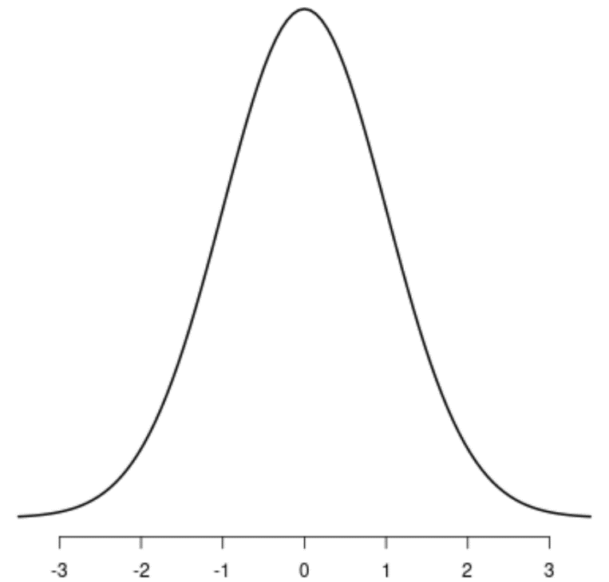

It has the following properties:

* Bell shaped
* [Symmetrical](https://www.statology.org/symmetric-distribution/)
* [Unimodal](https://www.statology.org/unimodal-distribution/) – it has one “peak”
* Mean and median are equal; both are located at the center of the distribution
* About 68% of data falls within one standard deviation of the mean
* About 95% of data falls within two standard deviations of the mean
* About 99.7% of data falls within three standard deviations of the mean
* This tutorial shares 6 examples of real-world phenomena that actually follow the normal distribution.

### **Example 1: Birthweight of Babies**

* It’s well-documented that the birthweight of newborn babies is normally distributed with a mean of about 7.5 pounds.
* The histogram of the birthweight of newborn babies in the U.S. displays a bell-shape that is typically of the normal distribution:
* 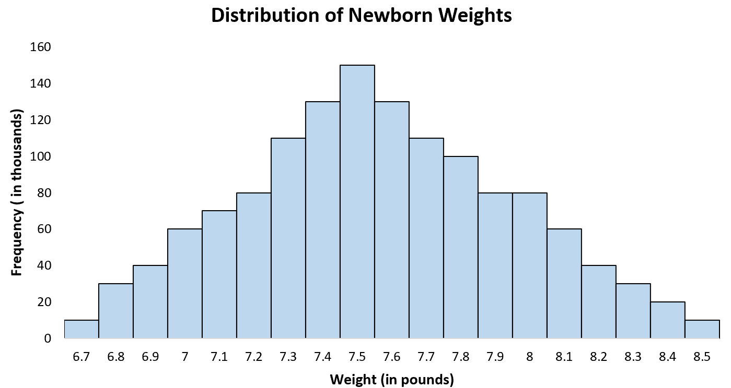

### **Example 2: Height of Males:**

* The distribution of the height of males in the U.S. is roughly normally distributed with a mean of 70 inches and a standard deviation of 3 inches.
* A histogram of the height of all U.S. male reveals a bell shape:
* 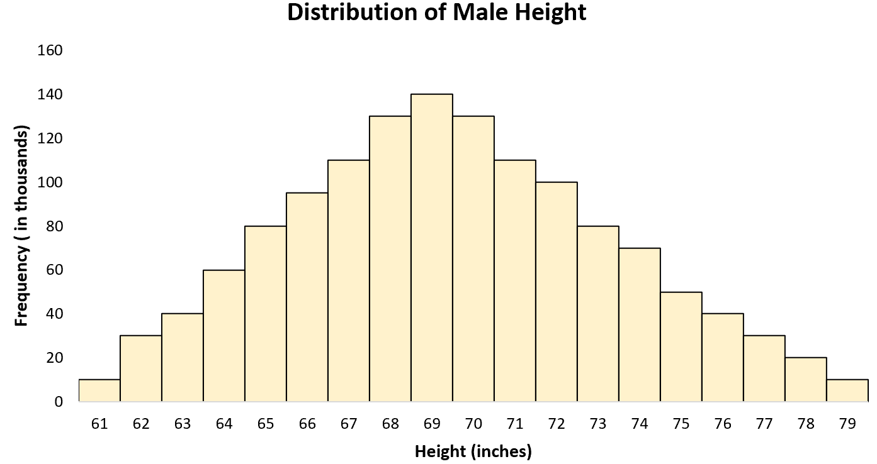

### **Example 3: Shoe Sizes**

The distribution of shoe sizes for males in the U.S. is roughly normally distributed with a mean of size 10 and a standard deviation of 1.

A histogram of the shoe sizes of all U.S. male reveals a bell shape with a single peak at size 10:

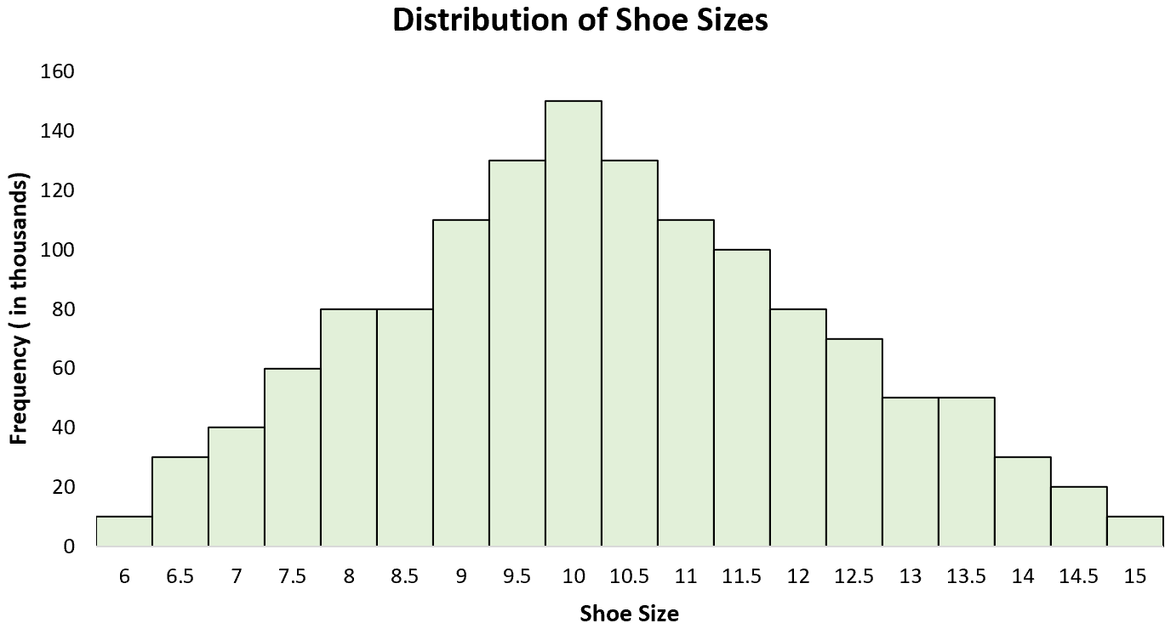

### **Example 4: ACT Scores**

The distribution of ACT scores for high school students in the U.S. is normally distributed with a mean of 21 and a standard deviation of about 5.

A histogram of the ACT scores for all U.S. high school students illustrates this normal distribution:

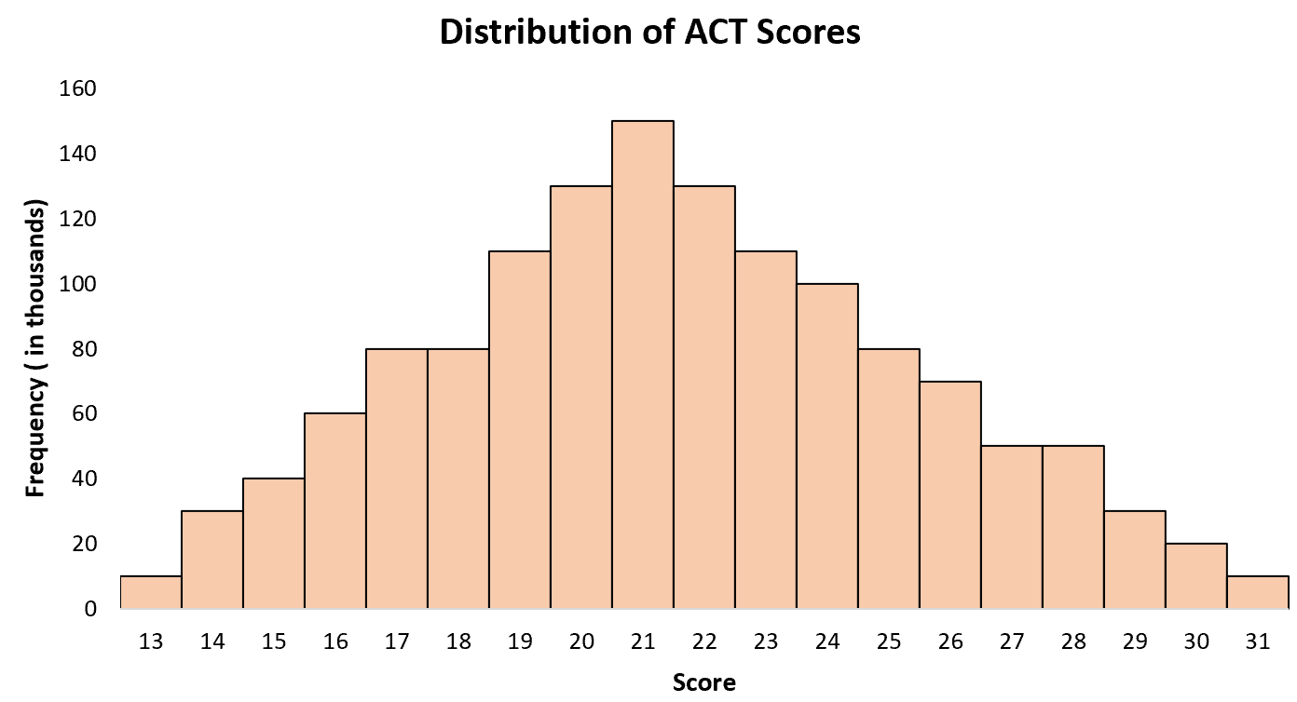

### **Example 5: Average NFL Player Retirement Age**

The distribution of retirement age for NFL players is normally distributed with

a mean of 33 years old and a standard deviation of about 2 years.

A histogram of this distribution exhibits a classical bell shape:

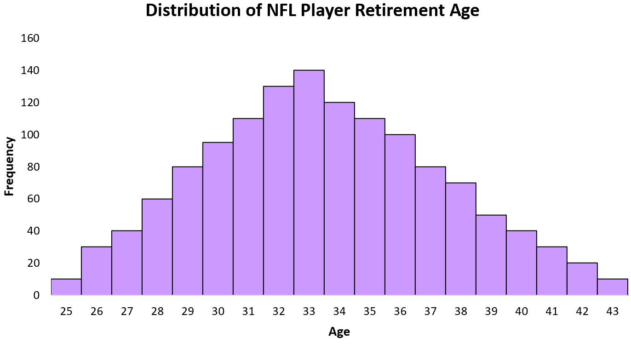

### **Example 6: Blood Pressure**

The distribution of diastolic blood pressure for men is normally distributed with a mean of about 80 and a standard deviation of 20.

A histogram of the distribution of blood pressures for all mean displays a normal distribution with a bell shape:

